From:

The Mystery Behind the Missing Malaysia Airlines Flight Isn’t Solved Yet

An ‘Atlantic’ cover article claimed to have closed the case on the unexplained disappearance of MH370 in 2014, but there are still gaps in the story

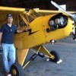

Jeff Wise
Jun 28, 2019
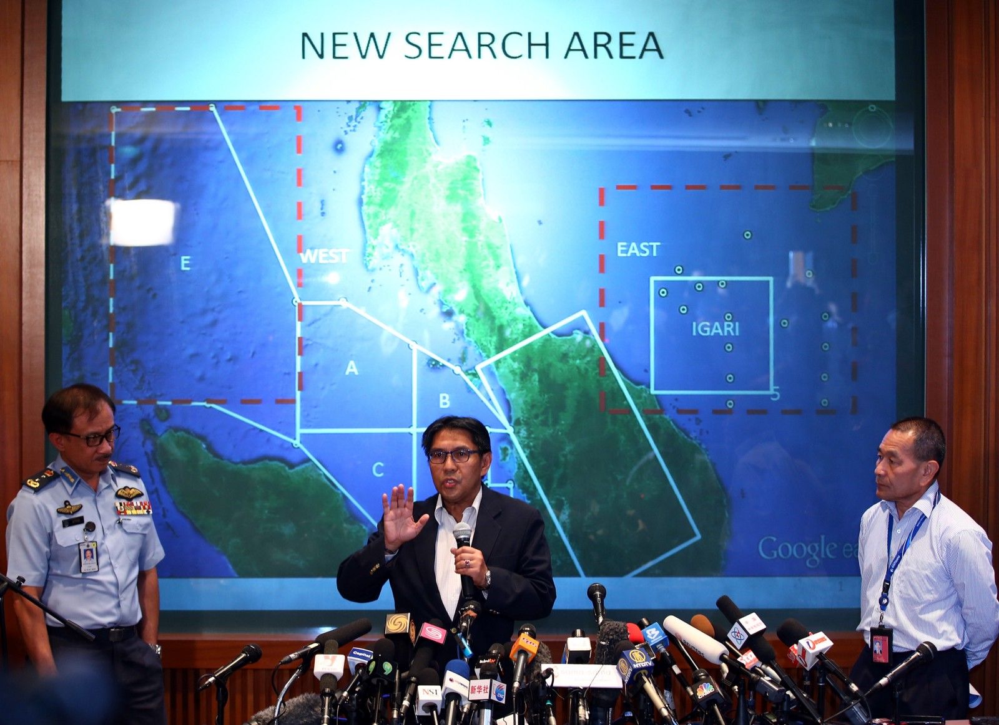
Credit: How Foo Yeen/Getty Images

William Langewiesche is a titan among aviation journalists. He has covered, in depth, some of the most important air disasters of our time for outlets such as the Atlantic and Vanity Fair. He also has extensive experience as a professional pilot. His credibility on the subject of aviation is, in a word, unmatched. So when he turned his hand to the greatest aviation mystery of our time — the disappearance of Malaysia Airlines Flight 370 — there was every reason to hope that he would bring some clarity, at last, to a story fogbound in confusion.
The 10,000 word Atlantic cover story posted on June 17, however, did not accomplish that. Langewiesche writes evocatively, and he wrangles a mountain of information, but he falls victim to a siren temptress: the yearning for a concise and reasonable solution to a deep mystery.
“The simple story is usually the right one,” Langewiesche told me, during one of the many conversations we had while he researched the project. Having immersed myself in the technical arcana of this story for more than five years — first as a CNN contributor, then as a freelancer for New York, Popular Mechanics, and other outlets — I [Jeff Wise] tried to show him that no simple answer can be made to fit the thicket of contradictory evidence that has grown since MH370 vanished on March 8, 2014 while flying from Kuala Lumpur to Beijing. As the saying goes, “everything should be made as simple as possible, but not simpler.” In the case of MH370, Langewiesche arrives at a solution that requires ignoring or dismissing whole categories of evidence.
It’s not a new solution. Langewiesche hitches his wagon to what has become the default, commonsense explanation, the one which the international authorities responsible for the search have implicitly held — the captain did it. This is a reasonable first pass at a theory of MH370. Since the plane was clearly taken by someone who knew what they were doing, and the only other person locked in the cockpit was the inexperienced first officer Fariq Abdul Hamid, then it must have been Captain Zaharie Ahmad Shah who purposefully turned the plane around and flew it off into the darkness until it ran out of fuel and crashed in the remote ocean. Case closed.
Ah, but already we run into problems. Why would Zaharie, a financially comfortable suburban dad whose hobbies included making instructional home-repair videos, spontaneously decide to kill not just himself but all 238 other crew and passengers on the plane? Langewiesche acknowledges that there is no clear evidence Zaharie was psychologically capable of such an act, but then gets around this by invoking malevolent forces that must have hushed such evidence up. Langewiesche declares that the Malaysian government was “the most corrupt in the region” and “furtive, fearful, and unreliable in its investigation of the flight.” In his telling, the absence of evidence is taken as proof of a massive cover-up.
To be sure, Malaysia is not Switzerland. It is a still-developing country where overall levels of professionalism and competence can leave something to be desired — a fact that colored the country’s response to the airplane’s disappearance. In particular, the Malaysian military has been only intermittently forthcoming about its radar detection of MH370, and to this day has not revealed all its data. But there is no evidence that the authorities carried out a deliberate whitewash of the overall investigation.
Langewiesche says of the 495-page final Malaysian report that “nothing in the report was of technical value” and that it “was stuffed with boilerplate descriptions of 777 systems.” This is flatly untrue. The report contains a great deal of previously unreleased technical information, including detailed descriptions and analysis of recovered debris, revelatory information about the plane’s cargo, and an exhaustive examination of the plane’s divergence from its planned flight path.
True, this particular report does not go into great detail about the captain’s background, but we know from a leaked report that the police did spend considerable effort looking for any evidence of guilt. According to an internal document not intended to be seen by the public, they were unable to find any.
There are other, more technical, reasons to doubt that Zaharie was the perpetrator. A whole subset of them hinge around the fact that after someone on MH370 turned all the electronic communications devices off, they turned one back on — an obscure piece of equipment called the Satellite Data Unit, or SDU. After the role of this device came to light, I asked several experienced 777 pilots if they knew how to turn an SDU off and on again. They all responded with variations of: “What on earth is an SDU?”
Langewiesche speculates that perhaps the reboot happened because Zaharie turned off all the plane’s electronics, including the circuit the SDU was on, in order to reduce the electrical load on the engines and thereby hasten his getaway. I find this a very hard idea to swallow, and I doubt that any pilot has ever deliberately done such a thing. Doing so would improve one’s performance by a miniscule amount, at the expense of crippling the aircraft in multiple ways. A rough terrestrial analogy would be turning off your headlights on a dark highway to make your car go faster.
Though technically arcane, the SDU reboot is a crucial part of the MH370 mystery, because it was the reboot that led to the six hours of electronic pings that for the first year after the disappearance were the only clues investigators had as to where the plane had gone. Occurring a mere three minutes after the plane flitted out of Malaysian military radar coverage, the reboot put the plane in a bizarre, perhaps unprecedented, electrical configuration. This configuration resulted, by astonishing coincidence, in signals that encoded in a clear but unverifiable way just where the plane was going. (Unverifiable, in the sense that the data did not encode GPS data or other clues that could confirm the validity of the clue.) No plane has ever left this particular kind of electronic breadcrumb trail before, and none ever will again.
Yet investigators accepted the data unquestioningly. They discerned quickly that it fell into two main types. The first, which Langewiesche called “distance value,” allowed them to reconstruct the route that the plane must have followed — or rather, a pair of equally valid solutions, one leading off to the southern ocean, the other Kazakhstan. The second, dubbed by Langewiesche “Doppler value,” indicated that the southern route was the correct one. Hence, investigators had a route and an endpoint. They knew where to find the plane.
One problem: When they looked there, they didn’t find the plane. So they doubled the search area. No dice. They doubled it again, to an area the size of Great Britain. Still nothing. Langewiesche dismisses this failure as inconsequential, saying that “even a narrow swath of the ocean is a big place.” This misses the point. While the ocean is indeed a big place, far too big to probe in its entirety, the data pointed towards a portion of the ocean that was indeed searchable. Electronic signals are mathematical entities which can be analytically deciphered to a calculable degree of precision. Those sent from MH370 indicated that it was in a certain, searchable area of the ocean. It was not. The signals lied.
But how can signals lie?
The fact that the signals contained erroneous information leads, as I see it, to only one possible explanation: it was deliberately corrupted by someone. As it turns out, only planes of
- a particular type,
- carrying a particular kind of SDU,
- on a particular kind of flight path,
- flying under a particular kind of satellite, and
- subscribing to a particular level of Inmarsat service,
would have been vulnerable to this kind of tampering. MH370 met all these criteria. It’s impossible to say what percentage of planes share the vulnerability, but it can only be a small number. This should have been a red flag for investigators.
As a journalist following the case from the beginning, this certainly was a major red flag for me. [Jeff Wise] It spurred me to consult with technical experts, who said that while part of the signal data could readily be hacked from aboard the plane, other parts could not. This remaining data was enough to generate an approximate flight track indicating that the plane would have traveled north and wound up in Kazakhstan, a Central Asian autocracy that functions as a client state of Russia.
As it happened, just before the disappearance Russia had staged a “hybrid war” invasion of Ukraine that combined standard military assault with information warfare overseen by the GRU (Russian military intelligence). Four months later, the GRU shot down MH370’s sister airplane, MH17, over Eastern Ukraine. The fact that only 15 planes out of the 15,000 or so commercially registered around the world were Malaysia Airlines 777–200s, and that two of them had come to grief in such a short span of time, seemed too unlikely to be mere coincidence. Digging deeper, I found that there had been three Russians onboard MH370, including one whose daughter later wrote on social media that her father was “alive and well.” As I later would write in my book, The Taking of MH370, the mass of evidence taken together strongly suggested that the plane had been hijacked by Russia.
To be sure, this proposition raises the inevitable question: Why? The unsatisfying answer is, we just don’t know. But the evidence that Russia was heavily involved [This allegation is reproduced below.] in the destruction MH17 is all but ironclad, and no other definitive explanation for MH370 has yet emerged. The best guess I can come up with is that Russia had decided to embark on a broad, aggressive attack against the West, and these two actions fit into an overall plan that included subverting the Brexit vote, tampering with the U.S. presidential election, poisoning the former Russian spy Sergei Skripal and his daughter in Britain, and much else.
I explained this all to Langewiesche in the course of our many discussions. He rejected it out of hand. One of his objections was that if the plane went north instead of south, then the debris later pulled from the ocean must have been placed there deliberately. That sounds like conspiracy talk — but there is substantial overlapping evidence that this was actually the case. Despite supposedly drifting in the ocean for years, for instance, none of the recovered debris pieces had marine life more than a month or two old. But Langewiesche finds the idea of planting evidence inconceivable — mainly, it seems, because a large proportion of the debris was found by an American named Blaine Alan Gibson. And here, I think, is where his story really goes off the rails.
Gibson is an odd bird, even in Langewiesche’s generous telling. A man with no visible means of support, he travels the world dressed like Indiana Jones, pursuing ancient mysteries and receiving signs from dolphins. Yet for some reason he turns out to be the only human on Earth able to go looking for pieces of MH370 and find them. Indeed, more than half of the recovered debris pieces that have been gathered have been collected by him, personally.
Twice, he has performed the feat — a feat that no one on Earth has been able to pull off, no matter how long they’ve been looking (and many people have been looking) — while TV cameras were rolling. I don’t think there’s even a word for how unlikely that is.

[One can google "Blaine Alan Gibson" MH17 "goose barnacles" or google "Blaine Alan Gibson" MH370 .
Two URLS one can then look at are
- https://www.quora.com/What-is-the-proof-that-the-debris-from-MH-370-was-not-planted Dates fom 2016, 2017.
- http://jeffwise.net/2016/03/17/bioforensic-analysis-of-suspected-mh370-debris/comment-page-1/ Apparently written about March 16, 2016.
]
Gibson loves to spin yarns about his past adventures, but he is guarded about his particulars. He claims, without evidence, that people have threatened to kill him for his debris-collecting. But if you care to dig there is a lot that you can learn about him — none of it included in Langewiesche’s story. Most interesting to me, given that the multiple neon arrows pointing at Russia, is that Gibson is a fluent Russian speaker who for three decades was the owner of a company called Siberia Pacific, which he founded, with two Russians from Kemerovo Oblast, in 1992.
Langewiesche spends an enormous chunk of his piece talking about Gibson, but doesn’t mention his Russia connections at all. He restricts himself to an uncritical telling of Gibson’s version of events, and that, more than anything else in the Atlantic story, is frustrating to me. Langewiesche first got involved in the topic because I reached out to him in 2017 hoping he’d help me get to the bottom of some curious claims that Gibson had made about a particular piece of debris.
- In a Facebook post, Gibson had said that locals had handed a piece to him after he visited a village and asked if they had anything that looked like wreckage.
- Later, he told an independent researcher that he had been visiting the village and saw a 7-year-old girl fanning a cooking fire with it.
- Then, he told someone else that he had spotted it while having breakfast at his pension; the owner’s daughter had opened a drawstring toy bag, and there it was.
Why was he telling contradictory stories? I wanted to find out, but knew that someone else would have to do the asking. I had been in text communication with Gibson for a long time, and interviewed him over the phone for a New York story in 2016, but he stopped communicating with me after I voiced some of my suspicions about his discoveries on my blog. I figured that given his insatiable appetite for media attention it would be impossible for him to turn down Langewiesche. And so it proved. (Gibson did not respond to a request for comment.)
Many twists and turns later, Langewiesche flew to Malaysia and spent several days hanging out with Gibson. Instead of sorting out his tangled past, Langewiesche fell under Gibson’s spell. The two had long, free-flowing chats. Langewiesche came away convinced that Gibson was an earnest soul.
In the end, of course, if Gibson really is an innocent free spirit who has dedicated his whole adult life, as Langewiesche apparently believes, to the cause of visiting as many countries as he can and “forgoing any chance of a sustained career and subsisting on a modest inheritance,” then his story has really no material bearing on the mystery of MH370 at all. He’s just a lucky eccentric who found a bunch of pieces that don’t really tell us much about what happened to the plane.
If, on the other hand, Gibson made his money as a legal consultant in Russia, as he told a journalist a few years ago, and if his area of professional expertise was the legal restrictions surrounding “secret cities” (i.e. those with nuclear power plants like Chernobyl), as a National Academies document indicates, then maybe he plays an important part in the story after all.
An advantage to being a literary lion is that your authority does a lot of your work for you. You don’t have to detail; you can assert. Langewiesche declares, for example, that “despite theories to the contrary, control of the plane was not seized remotely from within the electrical-equipment bay, a space under the forward galley. Pages could be spent explaining why.” And that’s the end of it. One wonders: if pages could be spent explaining, could not a sentence or two in a 10,000-word story?
There is no doubt that Langewiesche is a great magazine writer who has produced classic works of journalism, but there is something inherently “small-c” conservative about people who have won renown for their sagacity. They need to believe that the world as it exists is the same one in which they earned their laurels. Complicating evidence can be overlooked or ignored. Everything, in the end, must be simple. They shall declare it so.
- Aviation
- Malaysia Airlines
- Industry
- The Atlantic
- Airplanes
1.91K claps



Jeff Wise
Medium member since May 2019
Jeff is science journalist who lives north of New York City. He is the author of "Extreme Fear: The Science of Your Mind in Danger."

From: https://www.wsj.com/articles/hold-russia-accountable-for-mh17-11561589322

WSJ Opinion July 5, 2019

Hold Russia Accountable for MH17

European investigators charge four men with murder, but evidence of Russian guilt is powerful.
By
David Satter
June 26, 2019 6:48 pm ET
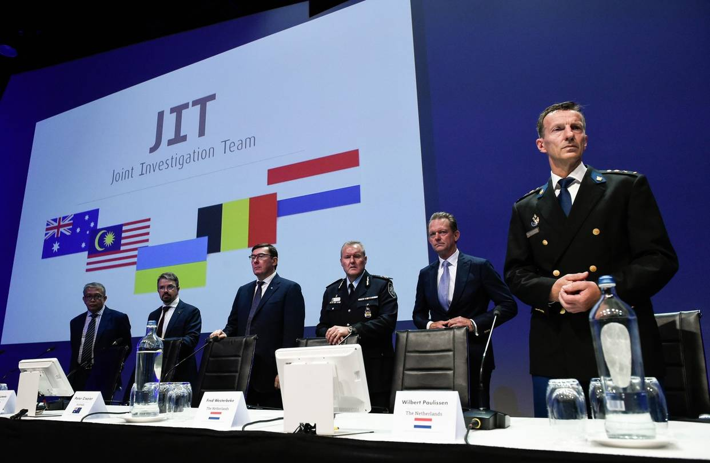
Members of the Joint Investigation Team in Nieuwegein, the Netherlands, June 19. PHOTO: JOHN THYS/AFP/GETTY IMAGES
Four men have been charged with murder in connection with the 2014 destruction of Malaysia Airlines Flight 17, which killed 298 passengers. But the Dutch-led Joint Investigation Team can’t produce justice in the case unless the U.S. is ready to hold Russian President Vladimir Putin accountable. Russian authorities are refusing to cooperate with the investigation, and Mr. Putin told journalists last week that there’s “absolutely no proof” Moscow participated. In fact, evidence that the Putin regime deliberately targeted a passenger jet is overwhelming.
The defendants include Igor Girkin, “defense minister” of the Donetsk People’s Republic, a Russian-backed Ukrainian separatist movement; and Sergei Dubinsky, head of the separatists’ intelligence service. On July 17, 2014, the day of the attack, Russian television initially reported that separatists had shot down a Ukrainian military airplane. At the same time, a message appeared on Mr. Girkin’s Twitter page in which he joyfully announced that his men had downed a Ukrainian Antonov An-26 cargo plane. The tweet was abruptly deleted after reports that the downed plane was a Boeing passenger jet. That convinced the world that the separatists had obtained a Buk-M1 antiaircraft unit capable of striking at high altitudes and had hit the passenger jet by mistake.
But in 2017 Mr. Girkin told Ekho Moskvy, a semi-independent Russian radio station, that the separatists never possessed a Buk-M1 or any other weapon capable of hitting a plane at 30,000 feet. Asked about the tweet, he said he didn’t write it and didn’t even have a Twitter account.
In May 2018, the Netherlands and Australia confirmed Mr. Girkin’s claim. The two countries, whose citizens constituted a majority of MH17’s passengers, said the Buk-M1 that destroyed the plane belonged not to the separatists but to the Russian 53rd Anti-Aircraft Missile Brigade, based in Kursk. The JIT last week released a recording of a conversation in which a contact tells Mr. Dubinsky that when the Buk crossed into Ukraine, it “came with a crew.”
The attack came while Moscow was seeking Western help to halt the advance of the Ukrainian army into separatist-held territory—efforts that dramatically intensified after MH17. Russia undertook an intensive campaign to deny responsibility for MH17. JIT reports that in a July 11, 2014, call, Vladislav Surkov, a close Putin adviser, assured Alexander Borodai, “prime minister” of the Donetsk Republic, that he had spoken with the highest Russian officials (“you can’t go any higher”) and that “decisive action” would soon create a break in the war situation.
In the first two days after the attack, Russian trolls posted at least 65,000 tweets denying Moscow’s involvement with the crime. According to Dutch researchers Robert van der Noordaa and Coen van de Ven, this level of Russian troll activity was unprecedented before the downing of MH17 and has been unmatched since.
Hours after the crash, Mr. Putin himself seemed to offer an “alibi” at a press conference in Brazil. Answering an unrelated question about a fatal accident on the Moscow metro, he said: “Responsibility is always personified. If two hunters fire into a bush and accidentally kill someone, insofar as it’s not possible to determine who fired the fatal shot, both of them are cleared of responsibility.”
Mr. Putin called President Obama immediately after the crash to tell him what had happened—which was odd, since neither the plane, the site nor any of the passengers were Russian. Later, at a Russian government meeting, Mr. Putin called for a minute of silence in memory of the crash victims, a step he didn’t take on behalf of the 24 people killed in the Moscow metro accident.
According to Andrei Illarionov, Mr. Putin’s former chief economic adviser and now a fellow at the Cato Institute, during the 10 days after MH17 was shot down, Mr. Putin had 24 conversations with Western leaders in which he conveyed a single message: The MH17 tragedy wouldn’t have happened but for the fighting in eastern Ukraine, and it was therefore imperative to stop the Ukrainian advance.
The discussions, Mr. Illarionov wrote, were “virtually non-stop.” Mr. Putin spoke with German Chancellor Angela Merkel and Australian Prime Minister Tony Abbott three times each and with Dutch Prime Minister Mark Rutte six times. In his note of condolence to Mr. Rutte, Mr. Putin wrote: “This tragedy once again confirms the importance of a peaceful resolution of the severe crisis in Ukraine.”
The evidence that Russia is responsible for deliberately downing MH17 is contained in details of the incident itself. According to the JIT, the Buk waited 20 miles from the Russian border for several hours, then went to a launch point directly under the L980 international air corridor. Russia closed the Rostov flight-information region, clearing the skies of air traffic that might have strayed into the corridor from the Russian side. The Buk waited 20 minutes, fired the single shot that destroyed MH17, and immediately returned to Russia.
The Buk’s infrared camera would have created a heat silhouette of the target, which in the case of a Boeing 777 is unmistakable. At the time, no Ukrainian fighter planes were within range. Four passenger jets, one of which was MH17, were in range.
The JIT [the Dutch-led Joint Investigation Team] has said there will be further criminal charges, but absentee trials of executors are insufficient to serve justice. The Trump administration has taken strong policy positions regarding Russia, but it has shied away from humanitarian issues. The evidence in the case of MH17, and Russia’s refusal to cooperate, is sufficient to hold Moscow accountable, to ban aircraft owned and operated by the Russian government from world airports, and to impose sanctions on Mr. Putin personally. Washington owes no less to the victims of MH17—and to anyone who gets on a commercial plane.
Mr. Satter is the author of four books about Russia and an expert witness in the case filed against Russia and President Putin by relatives of those killed on board MH17 in the European Court of Human Rights.
Appeared in the June 27, 2019, print edition.

